Walking routes

Walk 1- Cuckoo’s Field- approximately 30 minutes

From Laundimer house turn right on Bears Lane towards the woodland. At the first field entrance on the left (log across entrance) walk around the perimeter of the first field. Make sure you turn right at the line of hedgerow, which looks like it is in the middle of the field.
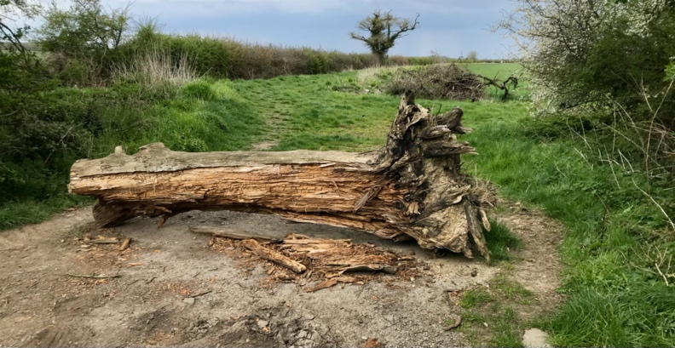

Log across field entrance

Walk 2- Laundimer Wood- Harry’s Park circuit- approximately 1 hour

From Laundimer House head right on Bears Lane towards the woodland. Continue straight on into the woodland passing a metal barrier gate. Continue to follow the woodland track until you come to a fork in the road.
Bear right along a very straight track (straight mile).

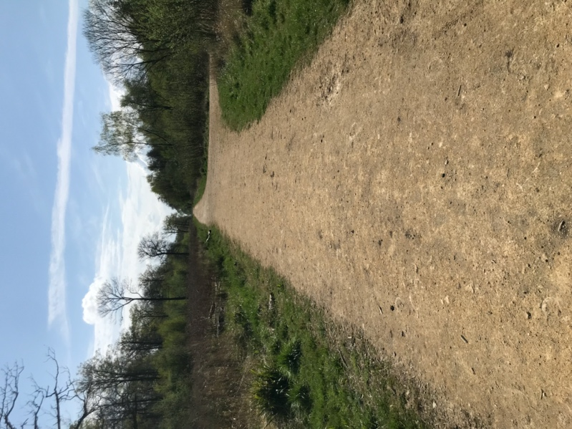
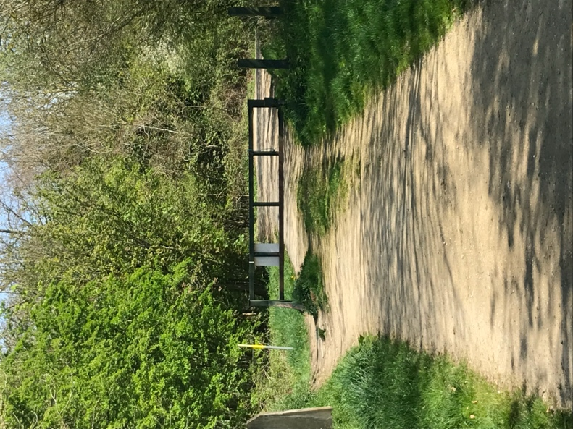

Straight track through wood Metal barrier gate (Brigstock side)

Follow this through and the track will eventually start to bend to the left and go downhill. Follow the dip and climb the small hill up to the second metal barrier gate.
You will arrive at a T-Junction where a tarmac road cuts across the woodland track. Turn left along the road walking towards ‘Harry’s Park’.

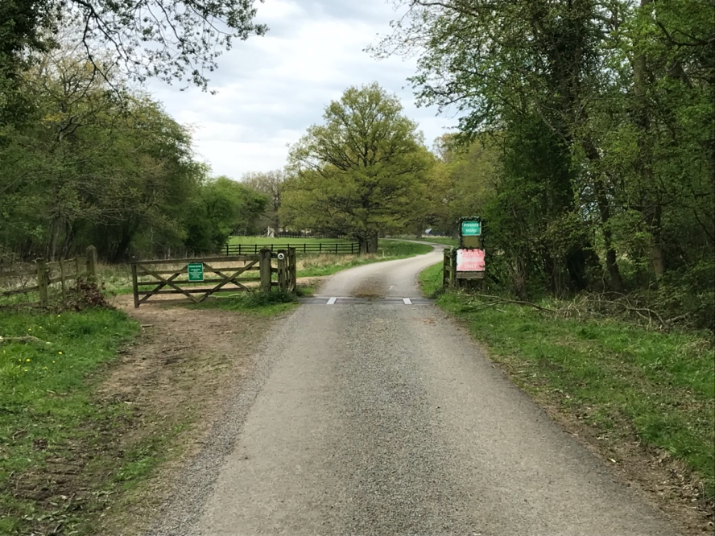
Go through the gate next to the cattle grid and walk through the deer park. You will see some country houses, sheep, horses and alpacas.

Entrance to Harry’s Park

Continue to walk along the road being aware of vehicles until you reach signs for ‘Bocase Farm’. Instead of going straight on to Bocase, turn left on the path around the galvanised metal gate on your left.
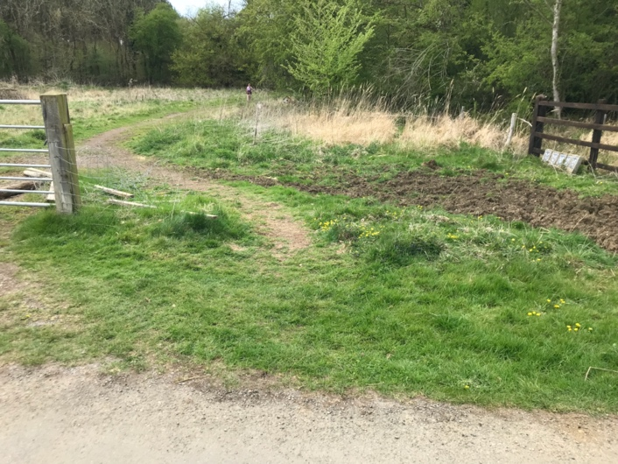
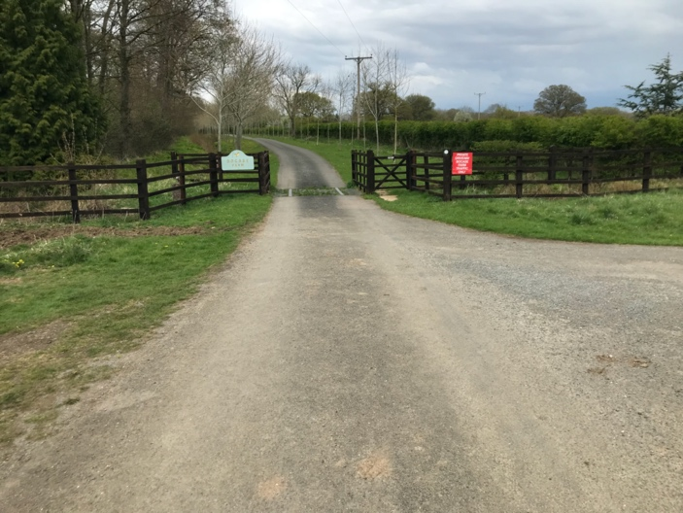

Bocase Farm entrance Galvanised gate and path around

Head back into the woodland. This is a lovely part of the walk through dappled shade. The track will take you back up to the fork in the road. Keep right on the track back towards the first metal barrier gate and back onto Bears Lane.
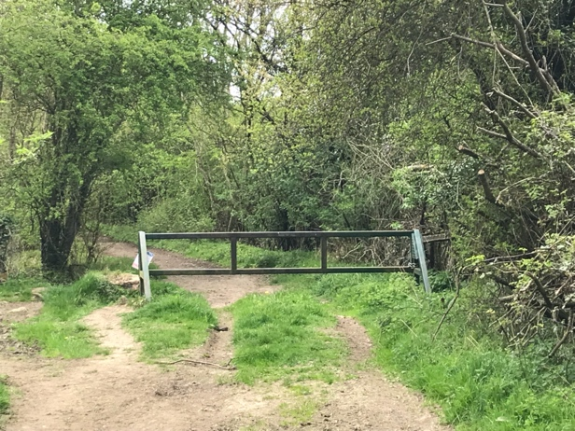
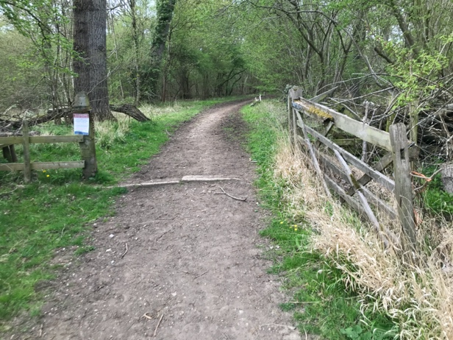

Woodland gate entrance Metal gate barrier to Bears Lane

Walk 3- Bocase Farm walk- 45 minutes -1 hour

From Laundimer house head right on Bears Lane towards the woodland. Turn left at the first field entrance on (log across entrance).

Walk to the top of the first field and turn right at along the hedgerow. Go through the gap in this hedge and into the next field. Keep right heading towards the wood through a wooden hand gate. This is a beautiful walk along a bridleway.
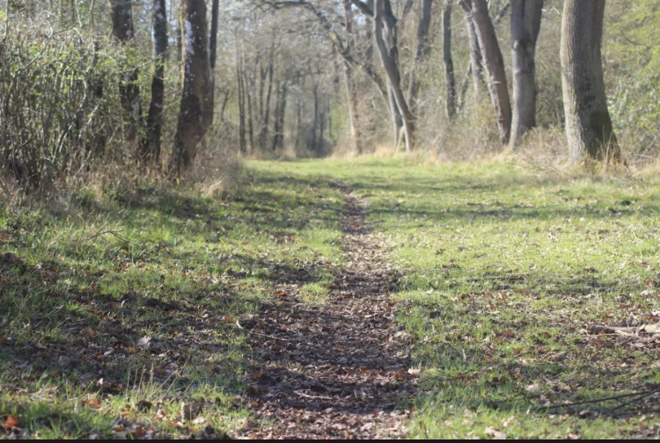
As you walk along the bridleway you will pass a large elevated water tank on the right and a bench for ‘weary walkers’. Eventually you will arrive at Bocase Farm. Walk past the farm noticing the knights and lions guarding the property and walk down the tarmac front drive.
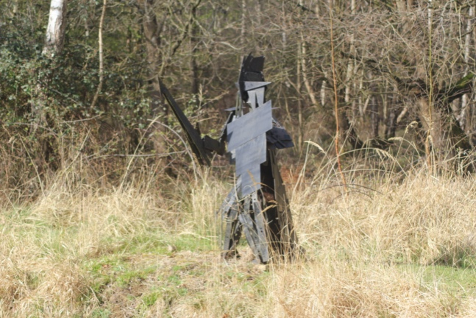

Bocase bridleway

At the end of the drive take an immediate right turn on the path around the galvanised gate. Follow the track through the wood back up to the fork in the road and bear right on the main track. Head towards the metal barrier gate and back to Bears Lane.

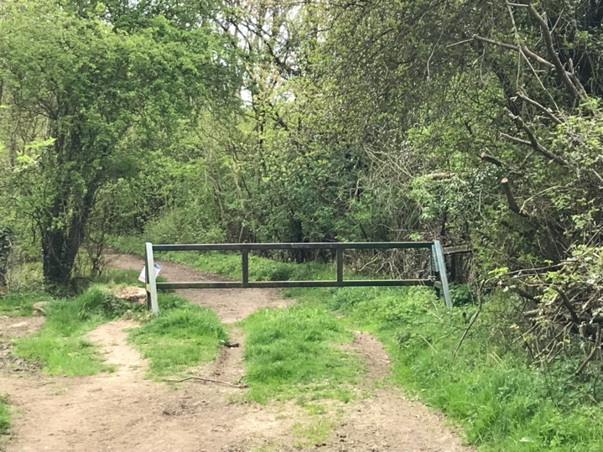
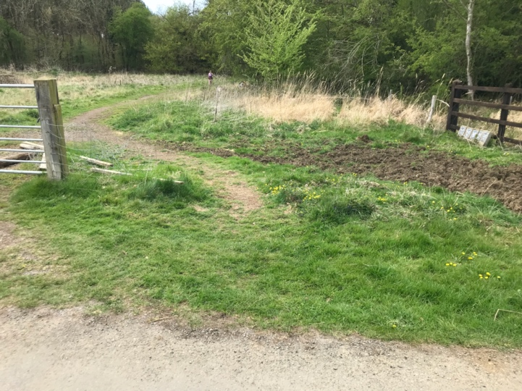

Path around galvanised gate Metal barrier gate to back to Bears Lane

Walk 4- To Brigstock village

From Laundimer House head right on Bears Lane towards the woodland. Continue straight on into the woodland passing a metal barrier gate. Continue to follow the woodland track until you come to a fork in the road. Bear right along a very straight track (straight mile).

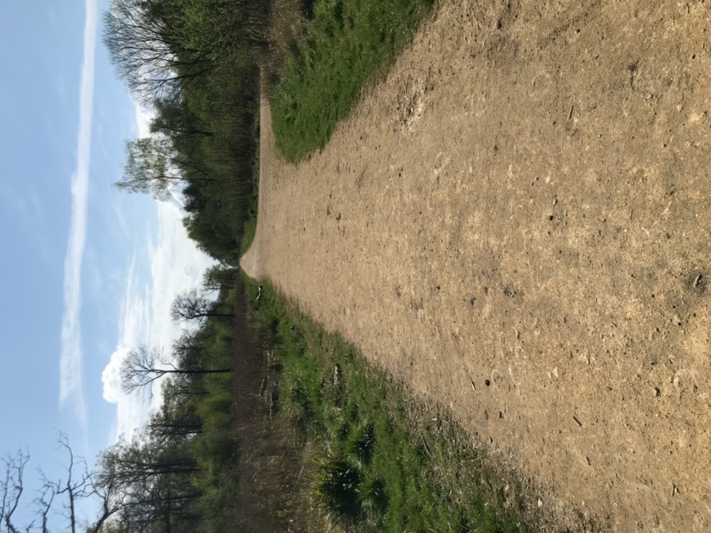
Straight track through woodland

Follow this through and the track will eventually start to bend to the left and go downhill. Follow the dip and climb the small hill up to the second metal barrier gate.

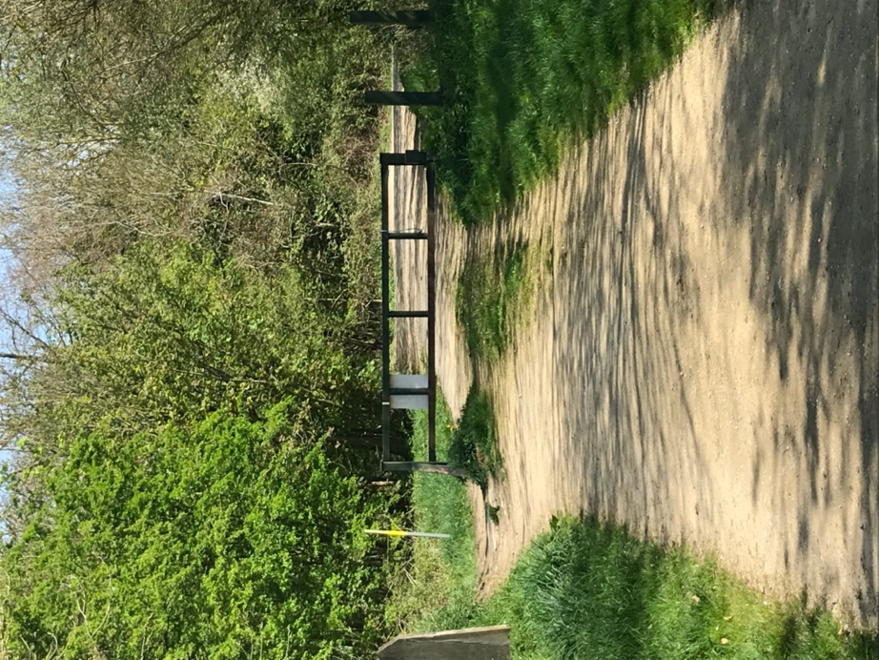

Metal barrier gate –
Brigstock side

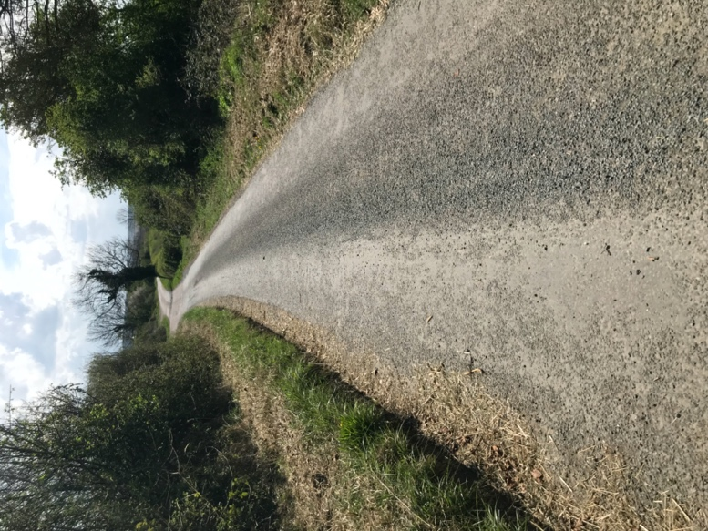
You will arrive at a T-Junction where a tarmac road cuts across the woodland track. Turn right down the tarmac road (Old Dry Lane North) towards the main road, leaving the woodland behind you.

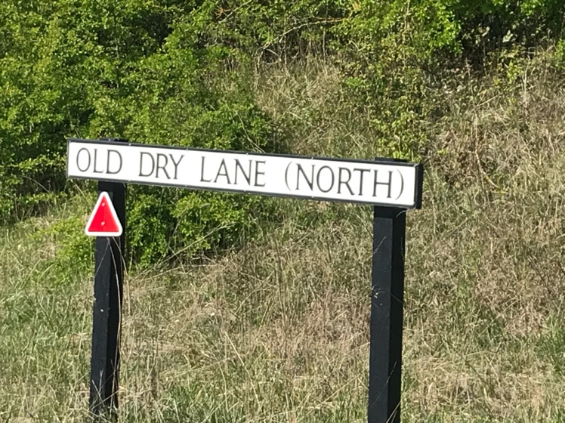

You will arrive at the very busy A6116 main road and the footpath to Brigstock is opposite Old Dry Lane. Carefully cross the road to the small path and head left toward Brigstock.

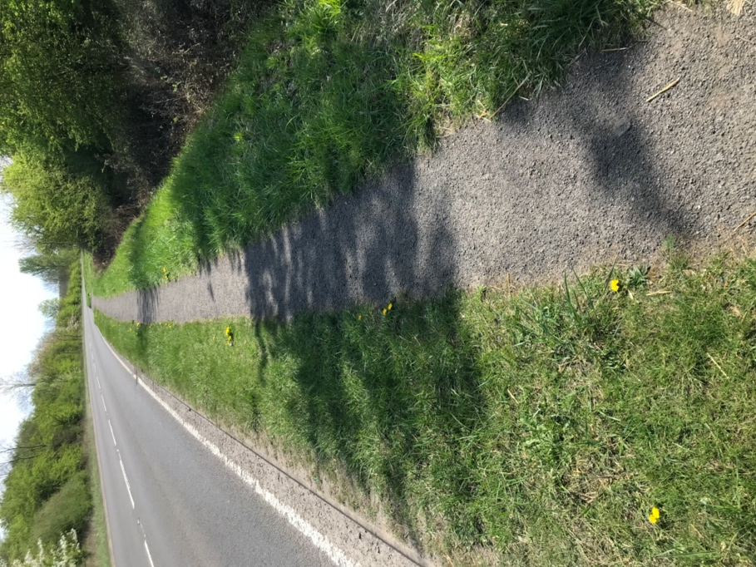

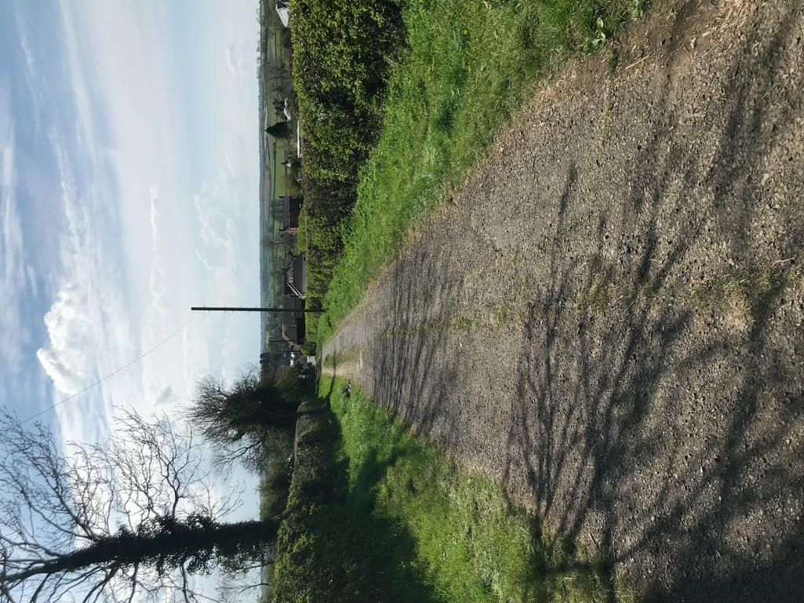

Footpath along A6116

Top of Old Dry Lane South

A galvanised gate with pedestrian gate will appear on the left (Old Dry Lane South). Head down this bridleway passing the cow pastures on either side. At the bottom of Old Dry Lane is an impressive factory building. This is Wallis Mill, a former clothing manufacturer.
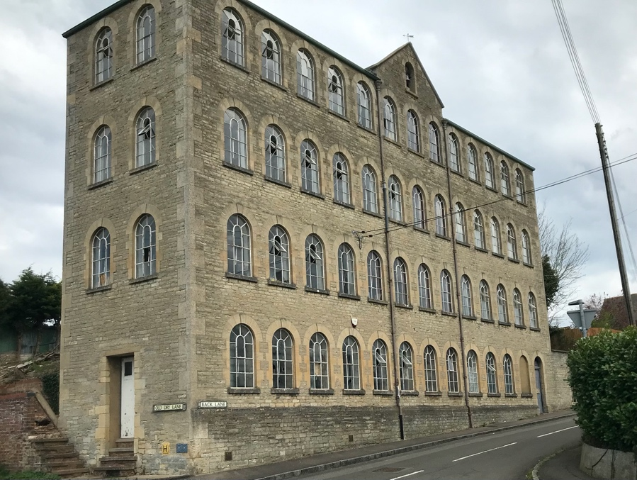

Taking the second road on the left (High Street not Back Lane). Walk down the High Street into the village of Brigstock. The café ‘Bake and Brew’ will appear on the left and further on is the Co-op and The Three Cocks Pub. If you follow the road around a severe right hand bend, there’s another pub called The Green Dragon and the village green and war memorial.
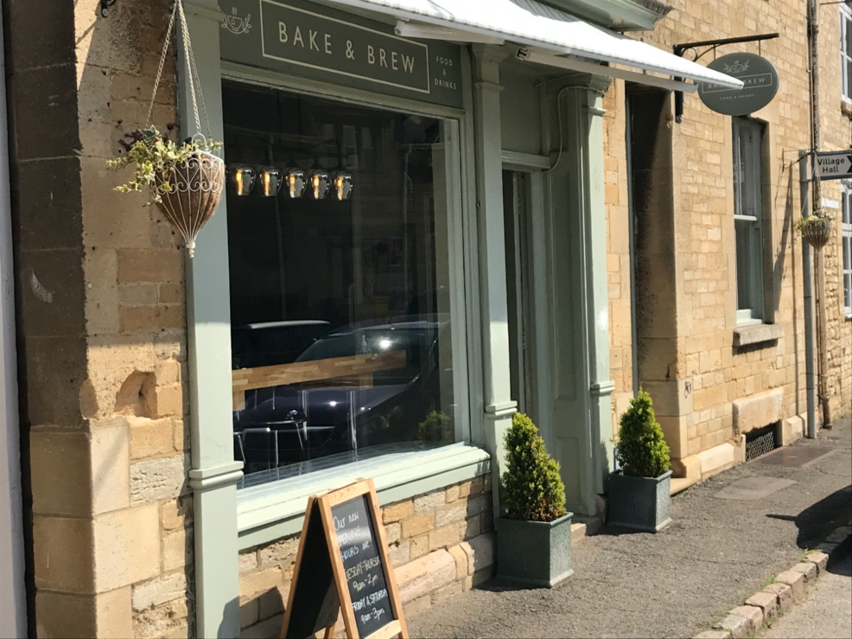

Bake and Brew Coffee shop is worth a visit.
Check opening times before you set off- they’re on Facebook

